**DAILY ONLINE ACTIVITIES SUMMARY**

|  |  |  |  |  |  |  |  |  |
| --- | --- | --- | --- | --- | --- | --- | --- | --- |
| **Date:** | **-06-2020** | | | | | **Name:** | **Shiza Amreen.J** | |
| **Sem & Sec** | **4th sem B Sec** | | | | | **USN:** | **4AL18CS078** | |
| **Online Test Summary** | | | | | | | | |
| **Subject** | | **--** | | | | | | |
| **Max. Marks** | | **--** | | **Score** | | | **--** | |
| **Certification Course Summary** | | | | | | | | |
| **Course** | **Introduction to Information Security** | | | | | | | |
| **Certificate Provider** | | | **GreatLearning** | | **Duration** | | | **5 Hours** |
| **Coding Challenges** | | | | | | | | |
| **Problem Statement:** [**Write a Java Program for Modular Exponentiation**](https://github.com/orgs/alvas-education-foundation/teams/2nd-year/discussions/133) | | | | | | | | |
| **Status: Completed** | | | | | | | | |
| **Uploaded the report in Github** | | | | | **Yes** | | | |
| **If yes Repository name** | | | | | **Lockdown_Coding**  <https://github.com/ShizaAmreen/Lockdown_coding> | | | |
| **Uploaded the report in slack** | | | | | **Yes** | | | |

Certification Course Details:

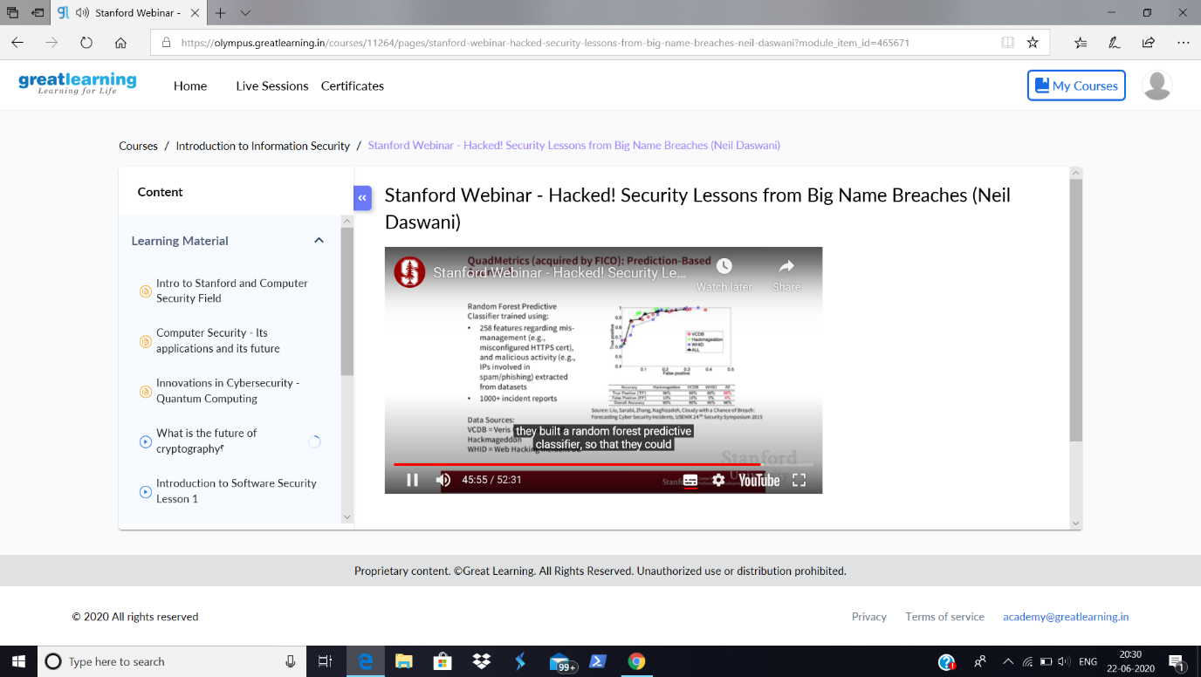

Today in the couse, I have learnt about Security Lessons.

Coding Challenges Details:

|  |
| --- |
| **Problem Statement:** [**Write a Java Program for Modular Exponentiation**](https://github.com/orgs/alvas-education-foundation/teams/2nd-year/discussions/133) |

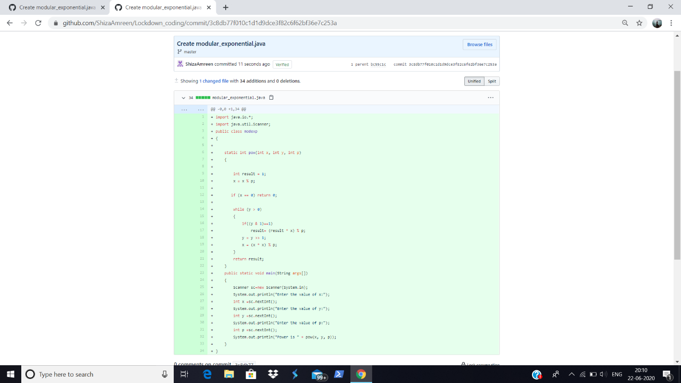

**I have written the code for given problem statement and uploaded it in my github repository, Lockdown_Coding.**

<https://github.com/ShizaAmreen/Lockdown_coding/commit/3c8db77f010c1d1d9dce3f82c6f62bf36e7c253a>